# ***Challenge Name :- Sph!nx's $urge***

**Description:** Welcome to the Sph!nx's $urge, Within lies a formidable test of your hacking prowess. The first layer shields its secrets behind a wall of obscured credentials, requiring the utmost cunning and perseverance to breach. Once inside, your true challenge awaits: navigating the labyrinth of permissions to elevate your status to that of an administrator, where the coveted flag awaits its liberator. Can you unravel the layers of security and claim victory

**Level:-** Medium

**Solution:**

**Step-1:** You will see a login button click and reach.

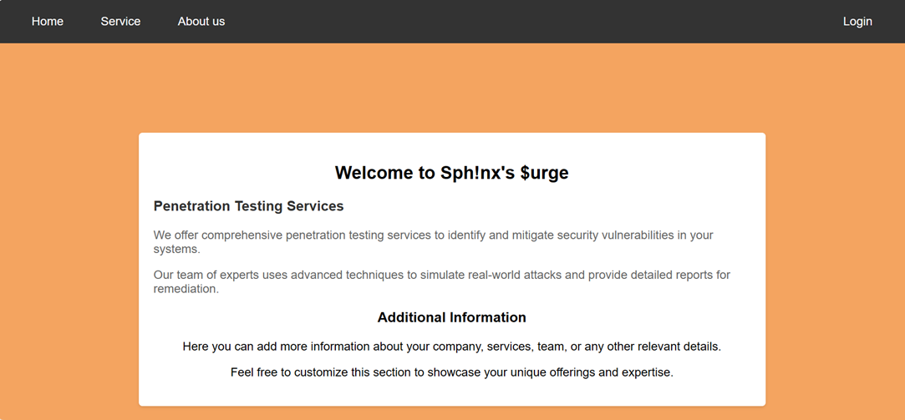

**Step-2:** You have to bypass authentication by common username and password. **Payload:** Username: admin

Password: johnson

You will get the password in Hint in JS file.

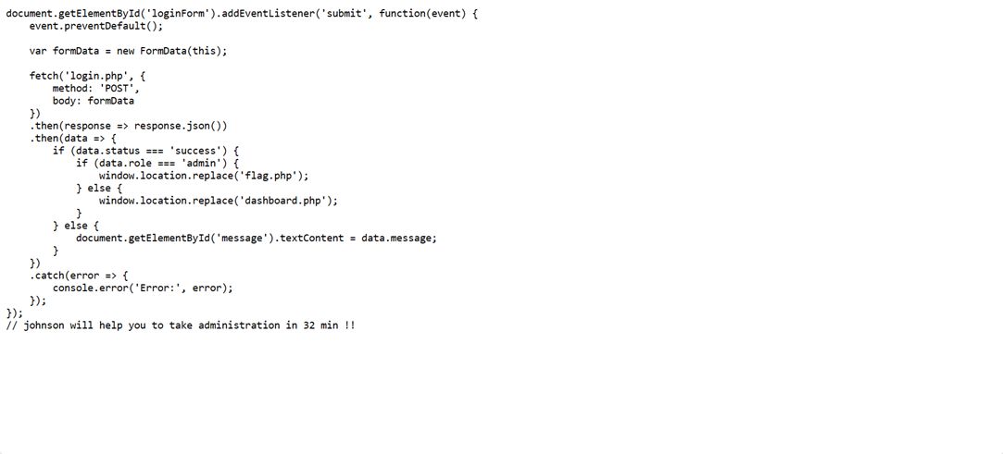

**Step-3:** You will redirect to dashboard , there is nothing if you are using Firefox or burp , when you inspect you will see some post request.

I am using Firefox when I inspect I see authenticate.php simple right click and do edit and resend . In body you will see some data.





Simple change role user to admin .

But there is trick in backend is authenticating it accept base32 encoded data so simple

admin→ base32 encode → MFSG22LO and then hit on resend.

**Step-4:** In network section you will see admin.php

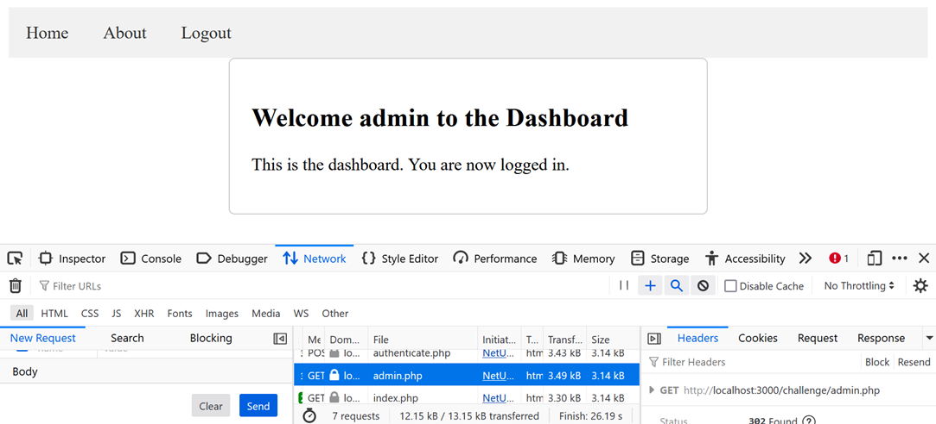

Simple open it in new tab. You will get the flag.

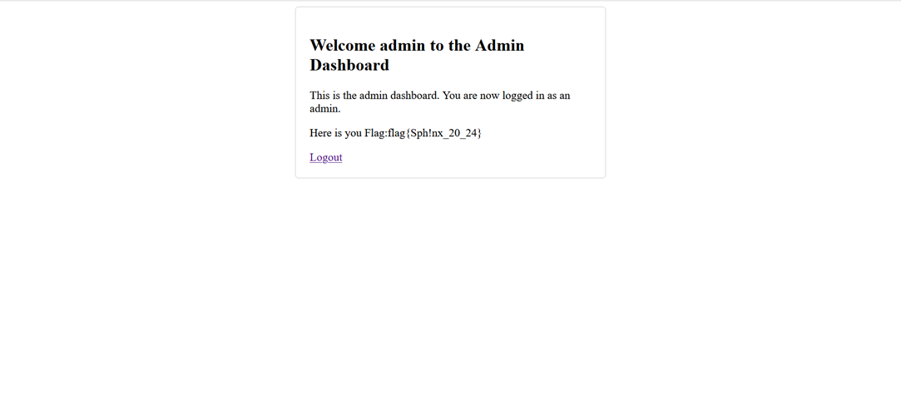

**Flag:** flag{Sph!nx_20_24}

This page is intentionally left blank